Francis Regalado December 22, 2019

CMP 464 Final Project

**Vehicle Collisions in New York City**

<https://data.cityofnewyork.us/Public-Safety/Motor-Vehicle-Collisions-Crashes/h9gi-nx95>

As a driver, I witness traffic accidents on a near daily basis. Many of these accidents take place around the same locations. Therefore, for this data project, I explored the open data for traffic accidents in the city of New York. This dataset involves accidents where there is at least $1,000 worth of damage. With this data, can go into detail and break down many different questions one might have. The data can be used to show which boroughs, zip codes, and streets are most likely to experience traffic accidents and warn pedestrians as well as motorists.

In this project, I wanted to answer several key questions with this dataset. Which streets are the most prone to traffic accidents? What is the main cause of traffic accidents? Which borough has the most traffic accidents? Is there a particular time of day or year where accidents are more likely to occur?

From July 2012 to December 2019, there have been a registered 1,624,091 accidents and counting. That is an alarming amount—over a million traffic accidents in a seven-year period.

The end goal of this project is to find common locations for accidents and propose stronger regulations (e.g., police officers in risky areas at times when accidents frequently occur) to try and reduce casualties. I sought to identify patterns in the data to aid in the future reduction of traffic accidents in New York City.

1. **Dates and Times**

To begin, I wanted to first find out at what times accidents most frequently happen. Using this dataset, I found out that accidents occur most frequently at 16:00, or 4:00 pm. During this time, 23,829 traffic accidents were reported. This time coincides with the beginning of rush hour. The second most frequent time would be 17:00, or 5:00pm, firmly in the middle of rush hour. During this time, there were a reported 23,390 accidents. The third most frequent time for car accidents happens to take place at 15:00, or 3:00pm. At this time, there were a reported 22,913 accidents. This time coincides with school dismissals and an increase of school buses on the road.

I also looked at the data in search of trends for dates. The date with the most accidents according to the data was January 21, 2014, the day after Martin Luther King Jr. Day. On this date, there were a total of 1,161 traffic accidents. Another interesting finding is that out of the top five dates for traffic accidents; four were between November and February, the colder months of the year. Surprisingly, two out of the top five dates were during Martin Luther King Jr. weekend (January 21, 2014 and January 18, 2015). This can be due to the fact that there are more cars on the road during holiday weekends, as people drive to either go on vacation.  **Time of day Number of accidents**

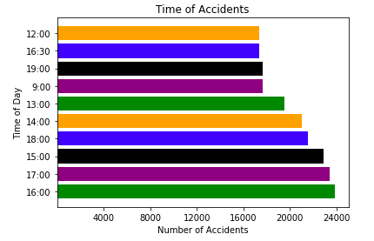 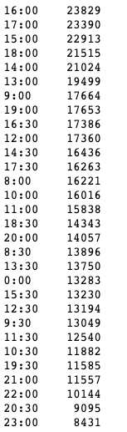

Figure 1 Accidents per time of day Table 1 Number of accidents per time of day (top 30 times of day)

**Date Number of accidents**

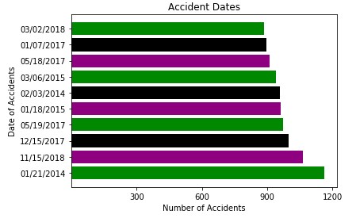 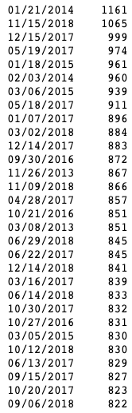

Figure 2 Accidents per date Table 2 Number of accidents per date (top 30 dates)

2. **Boroughs**

The next variable I reviewed was the distribution of accidents per borough. One may ask when looking at over 1.6 million data points, which borough is the most prone to accidents? Looking at the information, I found that Brooklyn is the borough with the most accidents, with 351,187 reported traffic accidents. The next borough is Queens, with 301,470 traffic accidents. Manhattan follows in third place, with 271,021 traffic accidents. Next on the list is the Bronx, with 157,838 traffic accidents. Finally, Staten Island is last, with 48,799 traffic accidents. Brooklyn and Queens are the boroughs with the largest population of residents drivers, so it correlates to the amount of accidents they have.

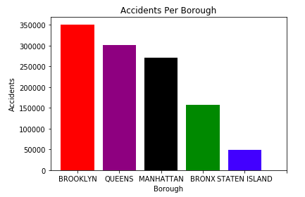

Figure 3 Accidents per borough

**Borough** **Number of accidents**

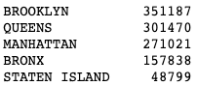

Table 3 Accidents per borough

3. **Roads And Streets**

The data is so detailed; we scan look closer and discover which is the street most prone to traffic accidents. The street with the most accidents happens to be Broadway located in Brooklyn (not Manhattan) with 16,100 accidents happening in this street alone. The second street with the most accidents is also located in Brooklyn—Atlantic Avenue, with 14,239 accidents. The third street is 3rd Avenue, also in Brooklyn with 11,642 accidents. The fourth street, Northern Boulevard, located in Queens, has had 11,358 accidents. The top 10 streets on this list all belong to either Brooklyn or Queens.

Breaking down the data by zip code, we find out that the top zip code per number of accidents is 11207 in Brooklyn, with 20,245 traffic accidents. The second zip code on the list is 11101 in Queens with 15,657. An error in the categorization of the data leads to these zip codes being listed twice each. The zip codes data support the street and borough level data, in that Brooklyn and Queens have the highest number of accidents.

**Street name** **Number of accidents** 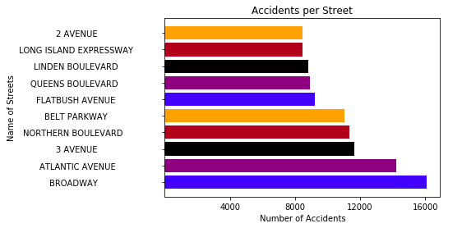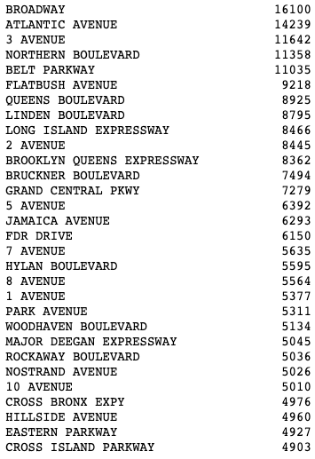

Figure 4 Number of accidents per streets Table 4 Number of accidents per street (top 30)

**Zip code Number of accidents**

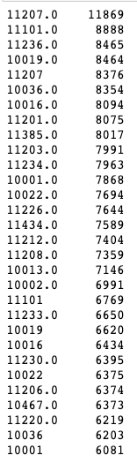

Table 5 Number of Accidents per zip code (top 30)

4. **Vehicle Type**

When examining the data, the top type of vehicle mostly involved in accidents is a Passenger Vehicle, with 715,236 accidents. It appears the “Passenger Vehicle” is a catchall category for all passenger non-commercial vehicles. The second type is Sports Utility / Station Wagon with 313,500 accidents. When I look at the categories beyond passenger vehicle, it seems as though Sports Utility/ Station wagons were listed twice. By combining both values, it gives a total amount of 446,378 traffic accidents, making it the vehicle most prone to accidents compared to all the other categories. Next, comes the Sedan, with 163,538 accidents. Following on the list, are Taxis, with 50,670 accidents. One would think Bus drivers or taxi drivers make up the most accidents, but the truth is that everyday drivers of New York City are the ones getting in most accidents.

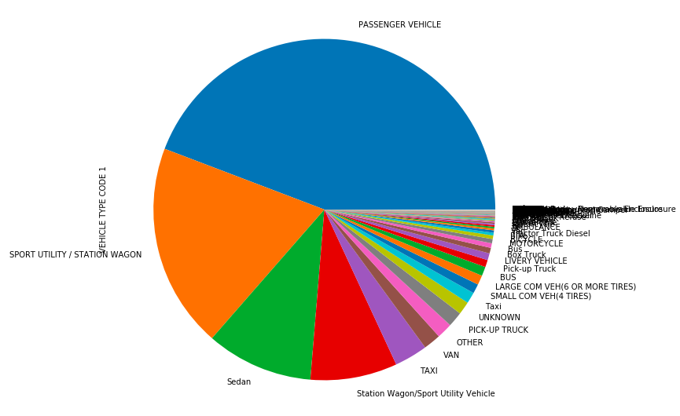

Figure 5 Accidents by vehicle types

**Vehicle Type Number of accidents**

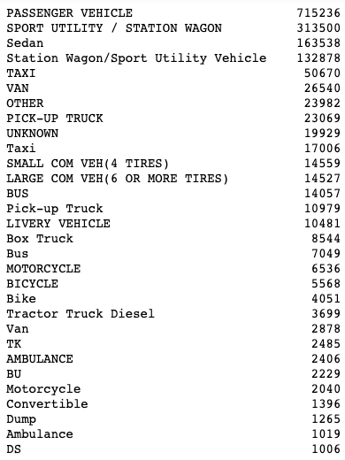

Table 6 Number of accidents by vehicle types (top 30)

5. **Reasons for accidents**

The data shows the most common reasons for accidents. A large amount of accidents don’t have a specified reason stated. Looking at the data, the most specified reason for accidents is the driver was distracted, which counts for 74,372 accidents. The following most common reasons are another vehicle, this accounts for 26,985 accidents. The third most common reason is failure to yield right of way. The fourth is drivers driving too closely. The fifth reason was driver fatigue or drowsiness. It seems that in the top five specified reasons, drivers were responsible for the accident, not road conditions.

**Reason for accident** **Number of accidents**

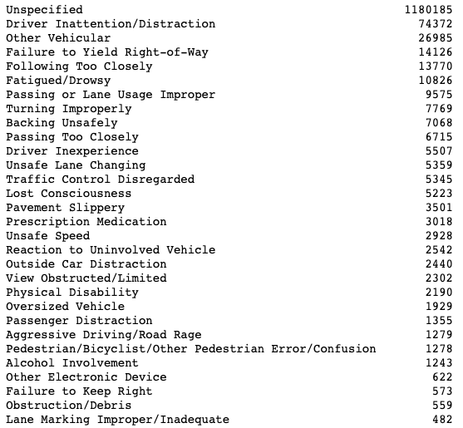

Table 7 Reasons for accidents

6. **Casualties and Injuries**

The data shows the number of times accidents resulted in injuries and or deaths. It also shows the number of deaths and injuries in individual accidents. There were 242,331 accidents in which 1 person was injured, and 45,548 accidents in which 2 people were injured. In the same manner, there were 1,770 accidents in which 1 person died, and 43 accidents in which 2 people died.

**Injuries Number of accidents**

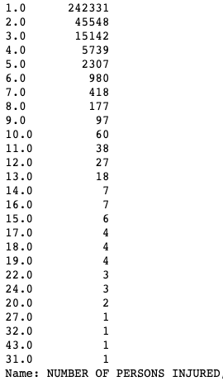

Table 8 Number of persons injured

**Deaths Number of accidents**

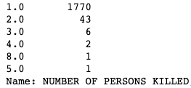

Table 9 Number of Persons killed

7. **Conclusion**

In this project, I wanted to answer several key questions with this dataset. Using the data set, I was able to determine which streets are the most prone to traffic accidents, the main cause of traffic accidents, and which borough has the most traffic accidents. I gave recommendations to increase driver’s safety on the roads.

This report begins with the mention that the data used filters for accidents in which there were at least $1,000 worth of damages. This is important financially but it does not take into account that there are thousands of injuries and deaths caused by these accidents. With all of this data, the city of New York can make changes so that everyone can be safer on the roads: motorist, bus drivers, taxi drivers and pedestrians alike.

To make the roads safer, the city could recommend that Police officers be stationed near areas where accidents most frequently occur. If officers are stationed near the area, they can monitor roads, seeing as how unsafe drivers cause most traffic accidents. This could reduce the number of accidents. If reckless driving causes the accidents, those motorists can be penalized leading to a change in their driving, reducing the number of future accidents. This data could also be used to warn pedestrians and drivers about the most unsafe roads and neighborhoods. The city could also implement other measure to keep drivers more attentive, since drivers being distracted was a main cause for accidents. The city can add more stop signs, as well as speed bumps in strategic roads. They can begin by looking at the most dangerous roads and boroughs. They can also increase police presence during the winter months and holiday weekends and have public awareness campaigns about safe driving. Hopefully these measures can make the roads safer for all New Yorkers.